Diffusion of Gases

In this experiment (demo) you will investigate what happens when two different gases diffuse through the air. Hydrogen chloride and ammonia will react together to give a white solid. When the two gases meet, this appears as white smoke in the air. Particles of hydrogen chloride are about twice as heavy as particles of ammonia.
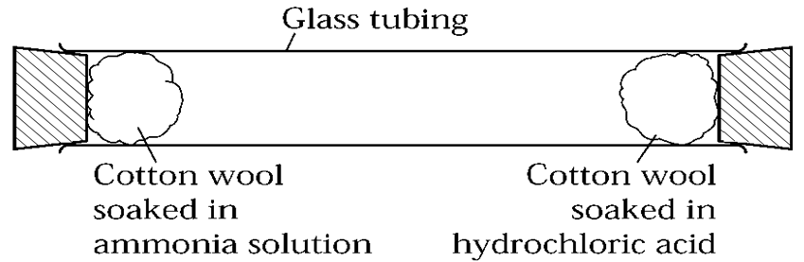

Recording your results
1. When your teacher puts the cotton wool in the tube, look carefully to see where the white smoke ring appears. Mark this clearly on the diagram.

Considering your results/conclusions

2. Which gas moved faster, ammonia or hydrogen chloride? ..……………………………………………...

3. Explain how you can tell this from the results ………………………………………………………………

…………………………………………………………………………………………………………………………

4. What would happen to the time taken to form the white smoke ring if the tube was heated? And where would the ring form? Explain why.
………………………………………………………………………………..……..………………………………..

……………………………………………………………………………….………………………………………..

……………………………………………………………………………….………………………………………..

5. On the above diagram draw a line to illustrate the path taken by an ammonia molecule and hydrogen chloride molecule as they moves along the tube

6. The particles in a gas move at a very fast speed. Explain why it took some time for the white smoke ring to form.
………………………………………………………………..………………………………………………………

………………………………………………………………………………………………………………………..

Extension: Give an equation to show the reaction between HCl and NH₃ to give a white smoke.
Given that KE = ½ mv² , explain why gases with a smaller mass tend to diffuse faster at the same temperature. Use the internet to research and explain this.

